The Drop-in Librarian
David Edens Tamatha Lambert
Instructional Services Librarian Director, ABAC Libraries
dedens@abac.edu tlambert@abac.edu
229.391.4986 229.391.4993
Creating a Search Alert via E-mail or RSS Feed
- To create a search alert, you must first run a search in Galileo. To avoid flooding your inbox or newsfeed with a plethora of alerts, try to make the search as specific as possible- via additional search terms or other limits.
- Next, sign in to Galileo. If you have never signed in to Galileo, you will need to create an account- this account is separate from your MyABAC, though you can use the same credentials if you wish.
- Select the “Share” button on the upper right side of your search results (red box in picture), then click on either E-mail Alert or RSS Feed under “Create an alert” (green box) to open the “Create Alert” window.
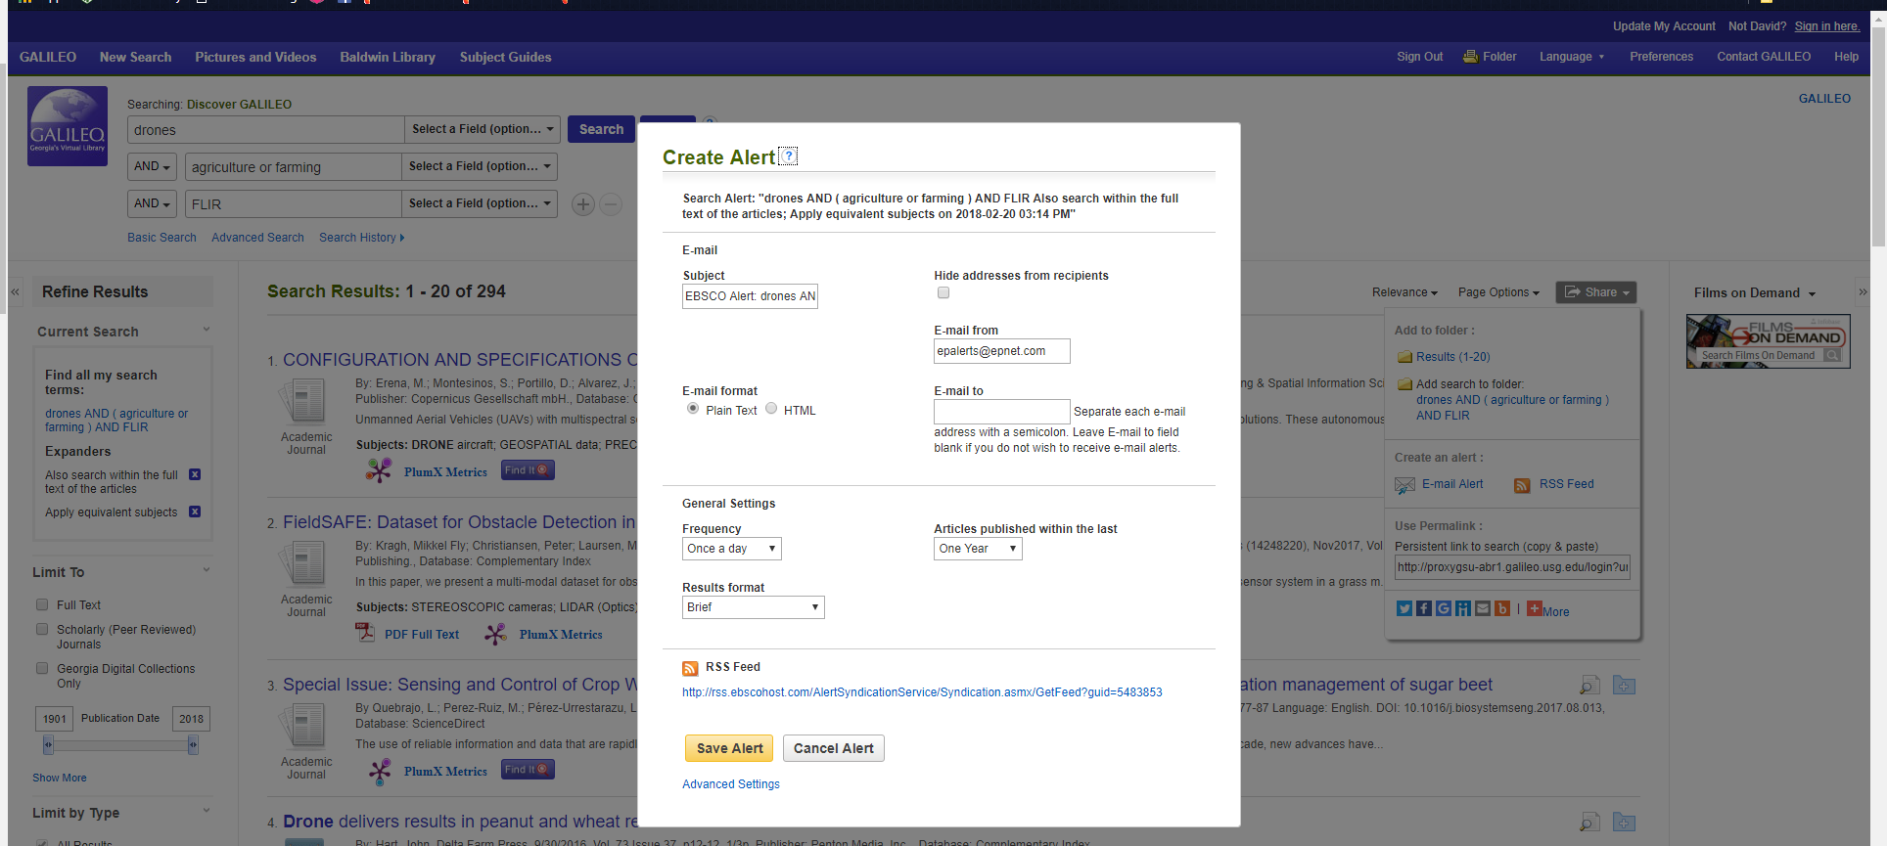
- You may edit the Subject field to determine the title of the e-mails, as well as altering the sender e-mail address. Make sure to enter your e-mail address in the “E-mail to” field! You also have options to determine frequency of e-mail alerts, how far back you wish the alert to reach (choices include 1 year, 6, 3, and 2 months, or no limit), and the formatting of the alert results (Brief, Detailed, or Bibliographic Manager/record).
- If you prefer an RSS alert in your newsfeed reader, simply copy the RSS Feed URL and plug it into your reader.

